**Analysis of Employee Reviews: Amazon, Apple, Facebook, Google, Microsoft, and Netflix**

IST 736 - Text Mining

Group E

Ning Shi - nshi02@syr.edu

Himadri Tewari - hstewari@syr.edu

School of Information Studies

The Syracuse University

06/14/2019

1. **Introduction**

The growing activity of web users has led to a rapid rise in the amount of textual information. As ever more textual information becomes available, it turns out that meaningful information is hard to obtain from huge masses of textual data. To handle this, methods of text mining are designed specifically for processing and analyzing vast amounts of texts. In general, text mining refers to the work of any system that analyzes large quantities of natural language text to identify lexical or linguistic usage patterns of interest, extracting potentially useful information. In contrast to data mining, text mining is a much more complex task. The semantic information contained in the text makes it a special data type, which is unstructured, amorphous, and difficult to process algorithmically. However, the text is still the most natural method to store information for communications between humans. Hence, the motivation for text mining is compelling, and its application potential is huge. Regarding the problem investigated in this work, most of it falls into the field of description analysis and supervised text mining. It belongs to the binary classification category, which means that a piece of words, for example, can be negative or positive in sentiment analysis.

As described, thanks to the rapid development of the Internet community, a large amount of valuable data is stored in the form of web documents. To better manage these documents, many researchers have been actively investigating the solution for automatic text categorization. The initial researches did not have a unified category to classify documents. One area of research concentrates on classifying documents based on their source or source style with statistically-detected stylistic variation. Another one is that of determining the genre of texts, that is subjective genres such as editorial version. Some others try to find general features indicating that subjective language is being used. All these work for genre categorization and subjectivity detection does assist in recognizing files while not help to understand each category, that is what that opinion actually is. When it comes to the sentiment-based classification, most previous research was at least partially knowledge-based. Later, Turney first applied a specific unsupervised learning technique based on the mutual information between document phrases, and three major machine learning methods were employed in the work of Pang, Lee, and Vaithyanathan to formally tackle the sentiment classification problem. Since then, this field began to receive heavy attention and was used to solve practical problems such as reviewing online comments.

The goal of this work is to apply text mining techniques to employee reviews analysis. Employee feedback is one of the most important resources for job-seekers. Employees provided feedback are used by potential job-seekers to find objective, unbiased information about working at a particular company. What is the company’s culture, leadership, chances for advancement, work-life balance and contributions the company is making to something important? If anyone is looking for a job, he/she will be referring to the employee review sites before applying to the company. Nowadays, people are interested not only in big salaries or attractive perks but also the work environment the company provides. A poor work environment could bring negative results like low employee morale, high turnover, and bad social media feedback which impact the number of people applying for jobs at those companies. Moreover, employee feedback and rating websites like Glassdoor or Indeed help the job seekers to research and understand how competitive a job or the company itself before accepting the offer. It also helps the job seekers to view which type of jobs are getting more attention and thus which company is looking for that kind of jobs. Employee feedback on the websites also help the employer or the companies to understand the pain points which employees have provided in their feedback and hence provide the company to restructure their infrastructure, benefits and work environment, to not only getting the talented resources but also to retain the existing employees.

**2. Analysis and Models**

**2.1 About the data**

**2.1.1 Choosing the Data Set**

The dataset was collected from the Kaggle website which contains 67k employee reviews for Google, Amazon, Netflix, Facebook, Apple, and Microsoft. The original dataset was collected from Glassdoor – a website where current and former employees provide feedback for their companies and management. The data source currently has been removed from the Kaggle. Figure 1, shows the first five rows from the dataset, some of the attributes and the corresponding values. The complete list of all the features in the initial dataset is given in Figure 2. The initial dataset has sixteen attributes. It contains the name of the company, review posting location, review posting date, current or former employee type, a summary of the review, pros and cons. It also contains additional important attributes which focuses more on the organization health like the company’s work environment, benefits provided to the employees and the senior management team. These attributes are measured on a scale of 1 to 5, with 1 being the poor rating and 5 being the highest. These attributes are overall rating, work-life balance rating, culture, and values rating, career opportunities rating, compensation, and benefits rating and senior management rating. It also contains the total number of review counts and link to the reviews. Clicking the link direct to the page that contains the review. However, it is likely that this link will be outdated.

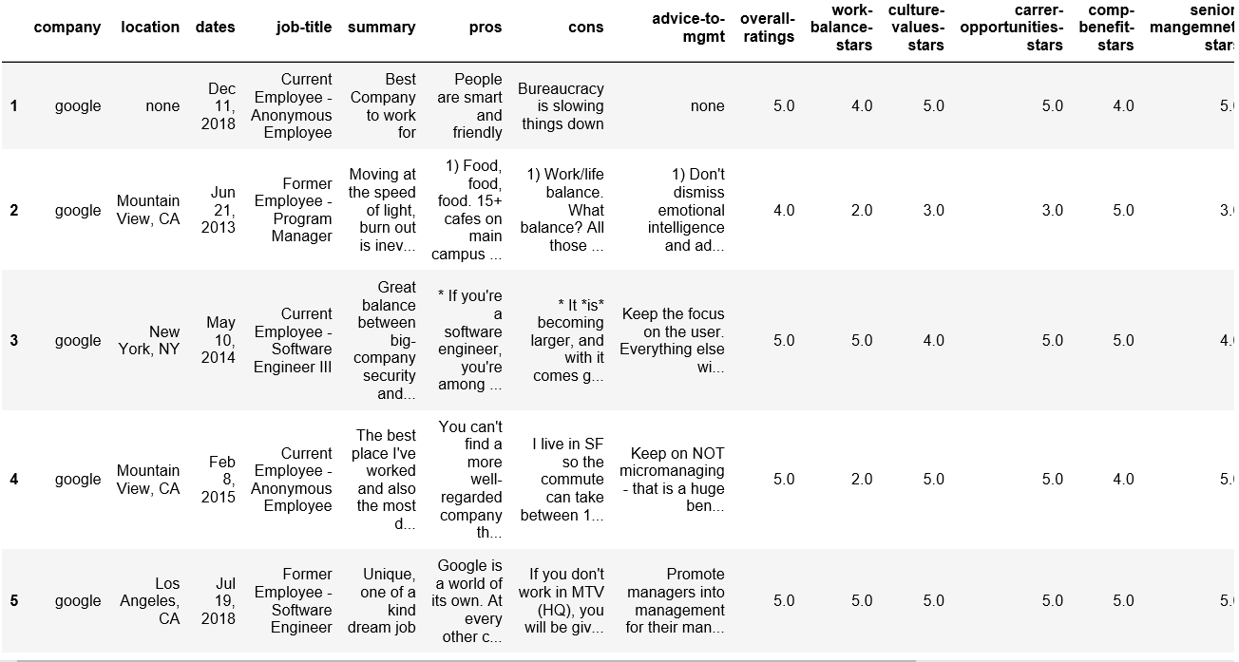

Figure 1. Tabular Form Summary

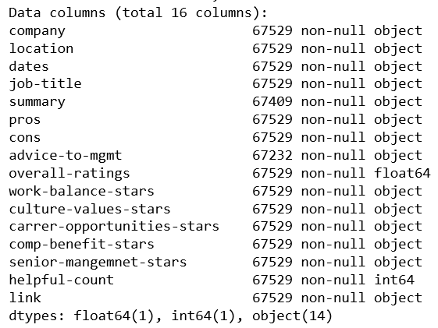

Figure 2. Dataset 16 Attributes

**2.1.2 Data Preprocessing**

Data preprocessing is the first level of data analysis technique where it transforms the raw data into an understandable format. The raw data is often inconsistent, incomplete, contain duplicate data and contain many errors. Using the raw data directly is not a viable idea as it lacks in lots of information and most of the time this data cannot be processed through a model. So, it is very important to preprocess the data for better analysis and sending through the model. It involves multiple steps in data preprocessing. Some of the important steps involved, importing the required libraries or packages, import the dataset, checking for special characters from the column, checking for nominal data, categorical data, checking for missing values, checking for null values, standardize the data and feature scaling.

For this project, as part of the data preprocessing, the following list of important libraries are imported. Random is imported for cross-validation and splitting the data into train and test set. Pandas is imported for data manipulation and analysis. Numpy is imported for scientific computation. Matplotlib and seaborn are imported for visualization purpose. Wordcloud is imported to generate the word-cloud. Sci-kit and nltk are imported for data preprocessing and model formation. The dataset was collected in CSV format, so to read the data pandas ‘read_csv’ function was used. After loading the dataset, the data-frame was summarized and the first five rows were analyzed. The dataset was then explored to find out if there are duplicate values present. Any duplicate values present were removed. Then it was analyzed to find out if there are null values present, and all the rows having null values are dropped. As part of the next pre-processing step, none values were replaced by the average or mean numbers. In the next step, the date column was converted to date time for better analysis.

**2.1.3 Data Analysis**

Data analysis focuses on systematically applying statistical and/or logical techniques on the existing dataset. The process involves multiple steps that include extracting and categorizing the dataset to generate different patterns, relations, connections, and other such valuable insights from it. In the exploratory data analysis, the data is explored to find patterns, spot anomalies, test hypothesis and to check assumptions with the help of summary statistics and graphical representations. The main idea behind representing the data pattern graphically as it helps the user to visualize the pattern and its relation. It helps to reveal the structural insight visually to the users. First, a summary of the overall rating distribution was measured for each of the companies. From the following picture, it can be interpreted that out of 6 companies, based on the average value, Facebook got the best rating whereas Netflix has the lowest rating. Referring to the standard deviation, Google has the lowest variation, whereas Netflix has the highest.

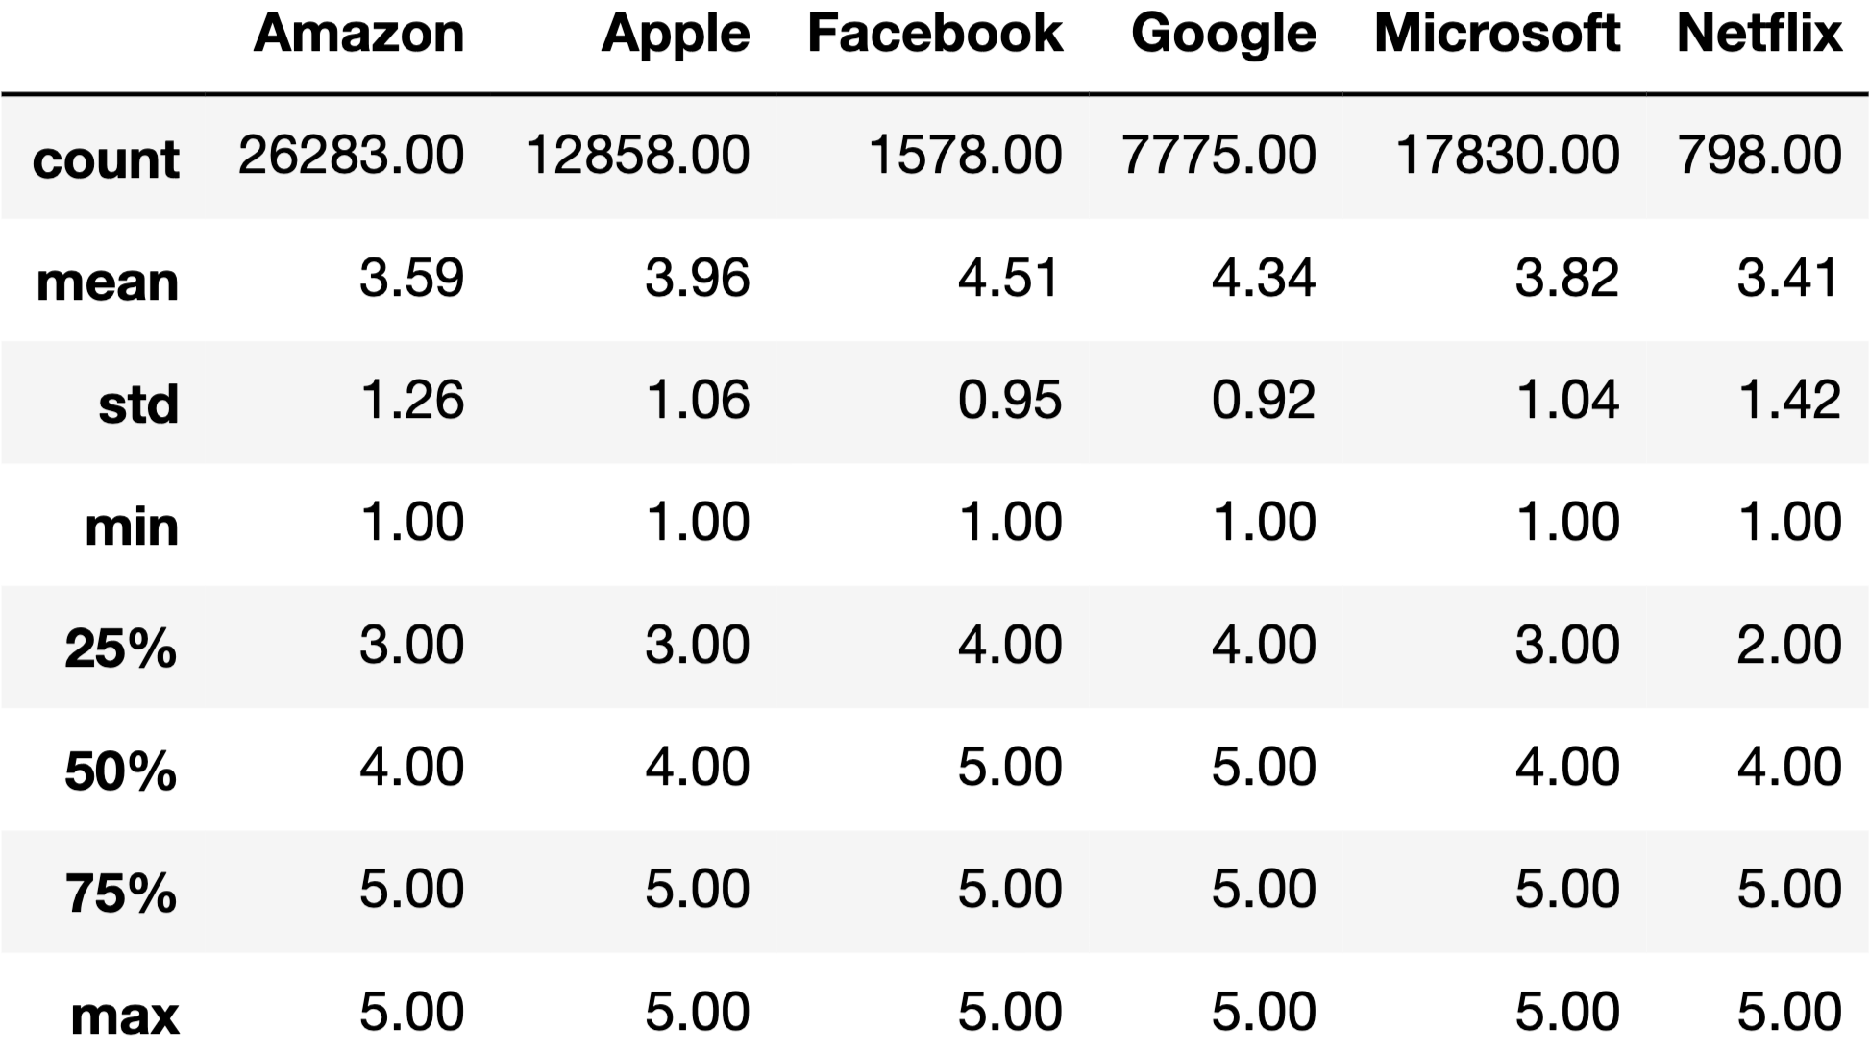

Figure 3. Statistical Description of Overall Ratings

The next analysis was done by visualizing the number of reviews for each company. From Figure 4, it can be observed that Amazon got the highest number of reviews, followed by Microsoft, Apple, Google, Facebook, and Netflix. Netflix has the least number of reviews. So, it can be interpreted that Amazon has the most number and mix of opinions. Whereas, Netflix has the least number of review comments, which suggest that as Netflix is a small company in comparison to other companies listed, that might be one of the reasons that it got the least number of feedbacks. The next analysis was done to visualize the general inclination of employee feedback over a period of ten years. Figure 5, shows that the feedback process has increased over the span of time. The employee review process was very less in the year 2009 and 2010, but started growing from the year 2012 onwards till the year 2017 and slightly dipped in 2018. It shows that employee reviews have become one of the important processes in shaping the company’s work environment, high employee morale, and healthy employee-employer relationship.

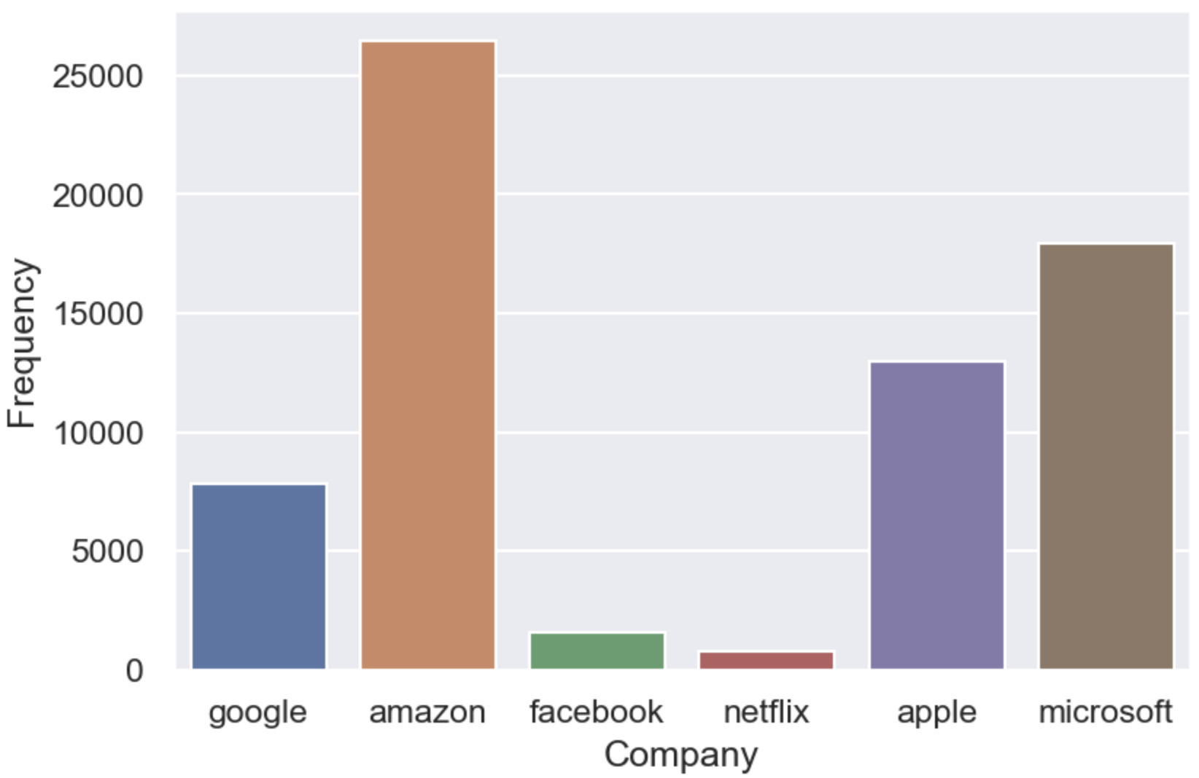

Figure 4. Review Count per Company

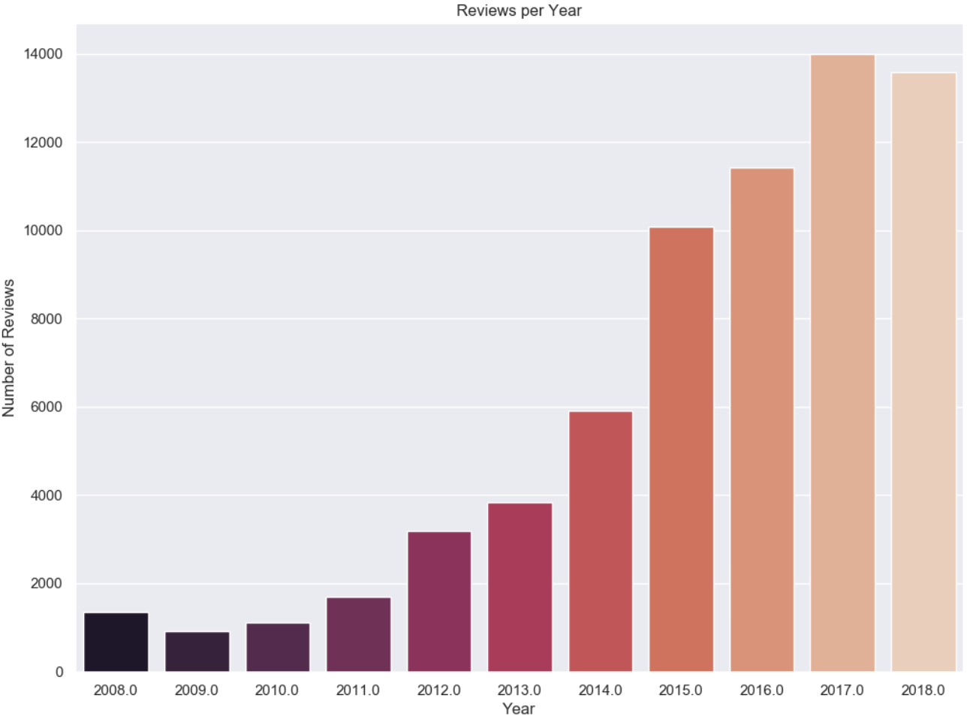

Figure 5. Review Count per Year

As the review trend shows the increasing importance of employee feedback process, the dataset was further analyzed to understand the distribution of employee review for each of the companies over a span of ten years. The objective behind the analysis was to understand the yearly distribution and the timeframe of the growth of employee review. It can be observed from Figure 6, that Amazon has got the highest number of reviews and the review process has started increasing from 2015 onwards. Employee feedback has increased in the last 4 years (2015 - 2018). For Microsoft, the review process started increasing from 2012 onwards and increased till 2015. Though it started declining from 2016 onwards till 2018, the bar was still higher than the one in 2012. So, the feedback process has increased in the last 7 years (2012 - 2018). For Apple, the process started increasing from 2014 onwards, which shows the growth in the last 5 years (2014 - 2018). For Google, although it started increasing from the year 2014, from 2015 till 2018, it maintains a steady state of the process. To calculate the time frame, it also got the most feedback in the last 5 years (2014 - 2018). Facebook, which was founded in the year 2004 was the in the list of companies which got a very smaller number of employee reviews. By referring to the visualization, it can be observed that the employee feedback went up in 2012, but then it declined the next year and again started increasing and it got the most feedback during the last 4 years (2015 - 2018). In comparison to Facebook, though Netflix was founded long back (1997), it started gaining popularity during the year 2007 onwards when it started the online streaming facility. But when the employee feedback process was considered, it does not have a gradual growth, but always maintain a high feedback process. From the above visualization, it can be interpreted that most of the companies had seen a growth of employee feedback in a range of last four to five years, except for Netflix, as it has always had high feedback for the range of 12 years (2007 - 2018).

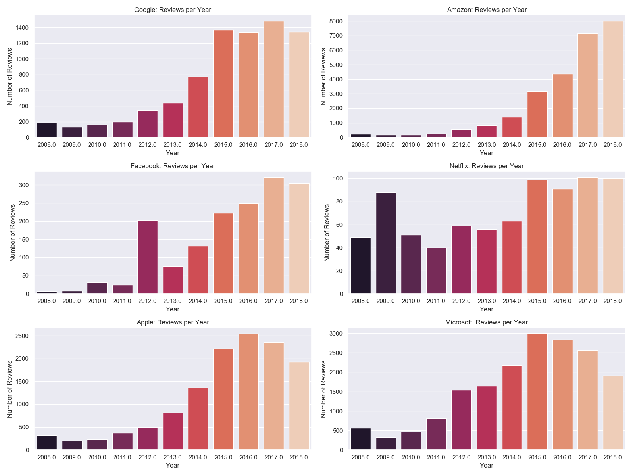

Figure 6. Review Count per Company per Year

As the last few analyses show the increase in the employee feedback process, the next process was to understand the type of employees who are providing feedback to the companies. In Figure 7, the job title column was plotted on the x-axis and the number of reviews for each company was plotted on the y-axis. To explore more on that, the review count of former employees is compared with the current employees for each of the companies. Based on the visualization in Figure 7, it can be interpreted that overall current employees have provided more reviews than former employees. It is observed that for Netflix, even though the review count is less compared to all other companies, the number of reviews provided by current and former employees are the same. While comparing the review count of Amazon, the difference of review count between former and current employees was the highest. As most of the reviews were from the current employees, it is difficult to interpret whether the reviews coming from current employees is a good thing or is it more bias in nature.

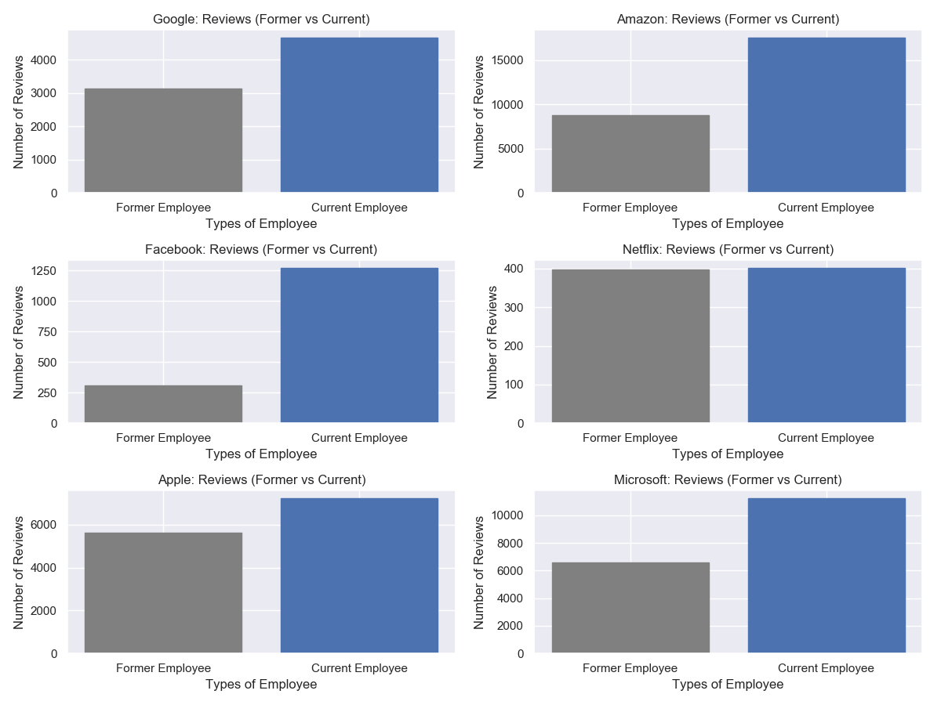

Figure 7. Review Count per Employee Type

To explore more on the employee types and their feedback process, it was required to analyze which employee type has given the highest rating to each of the companies. Figure 8, shows that former employees have given a better rating than current employees. So, from the previous and the current analysis, it can be presumed that former employees, after they leave the company, have better information on the company’s environment, work/life balance, career opportunities, compensation, benefits, etc., compared to which employees working currently in the companies won’t be able to realize as long as they don’t move to another opportunity.

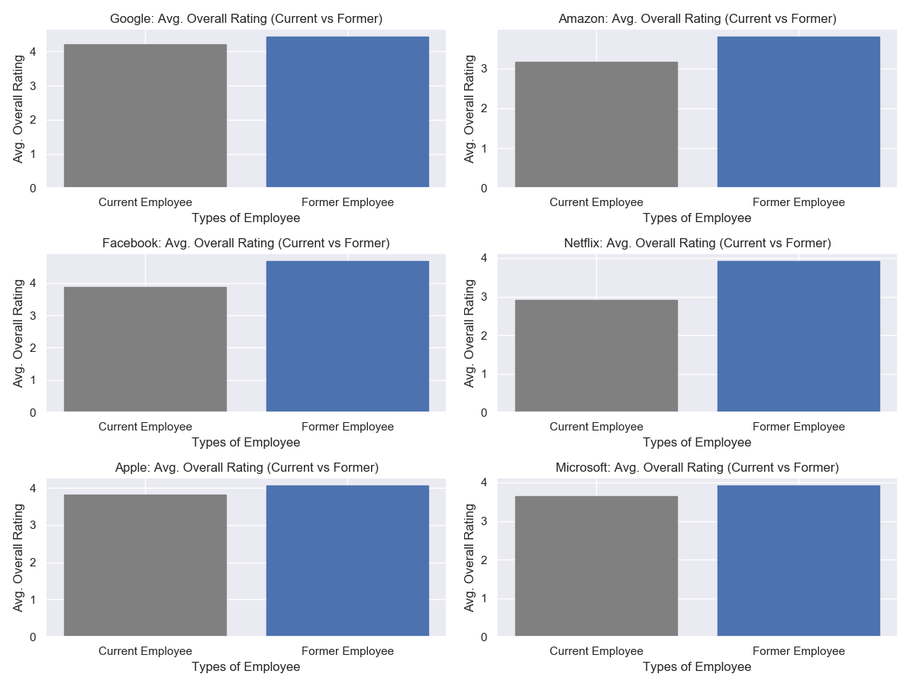Figure 8. Overall Rating per Employee Type

The dataset was further analyzed to find out the distribution of stars in a rating scale of one through five. The rating was done based on a certain list of organization criteria’s - Work Balance, Culture Values, Career Opportunities, Company Benefits, and Senior Management. These list of criteria’s determine how much companies value for their employees and whether companies today pay attention to the work environment they provide for their employees.

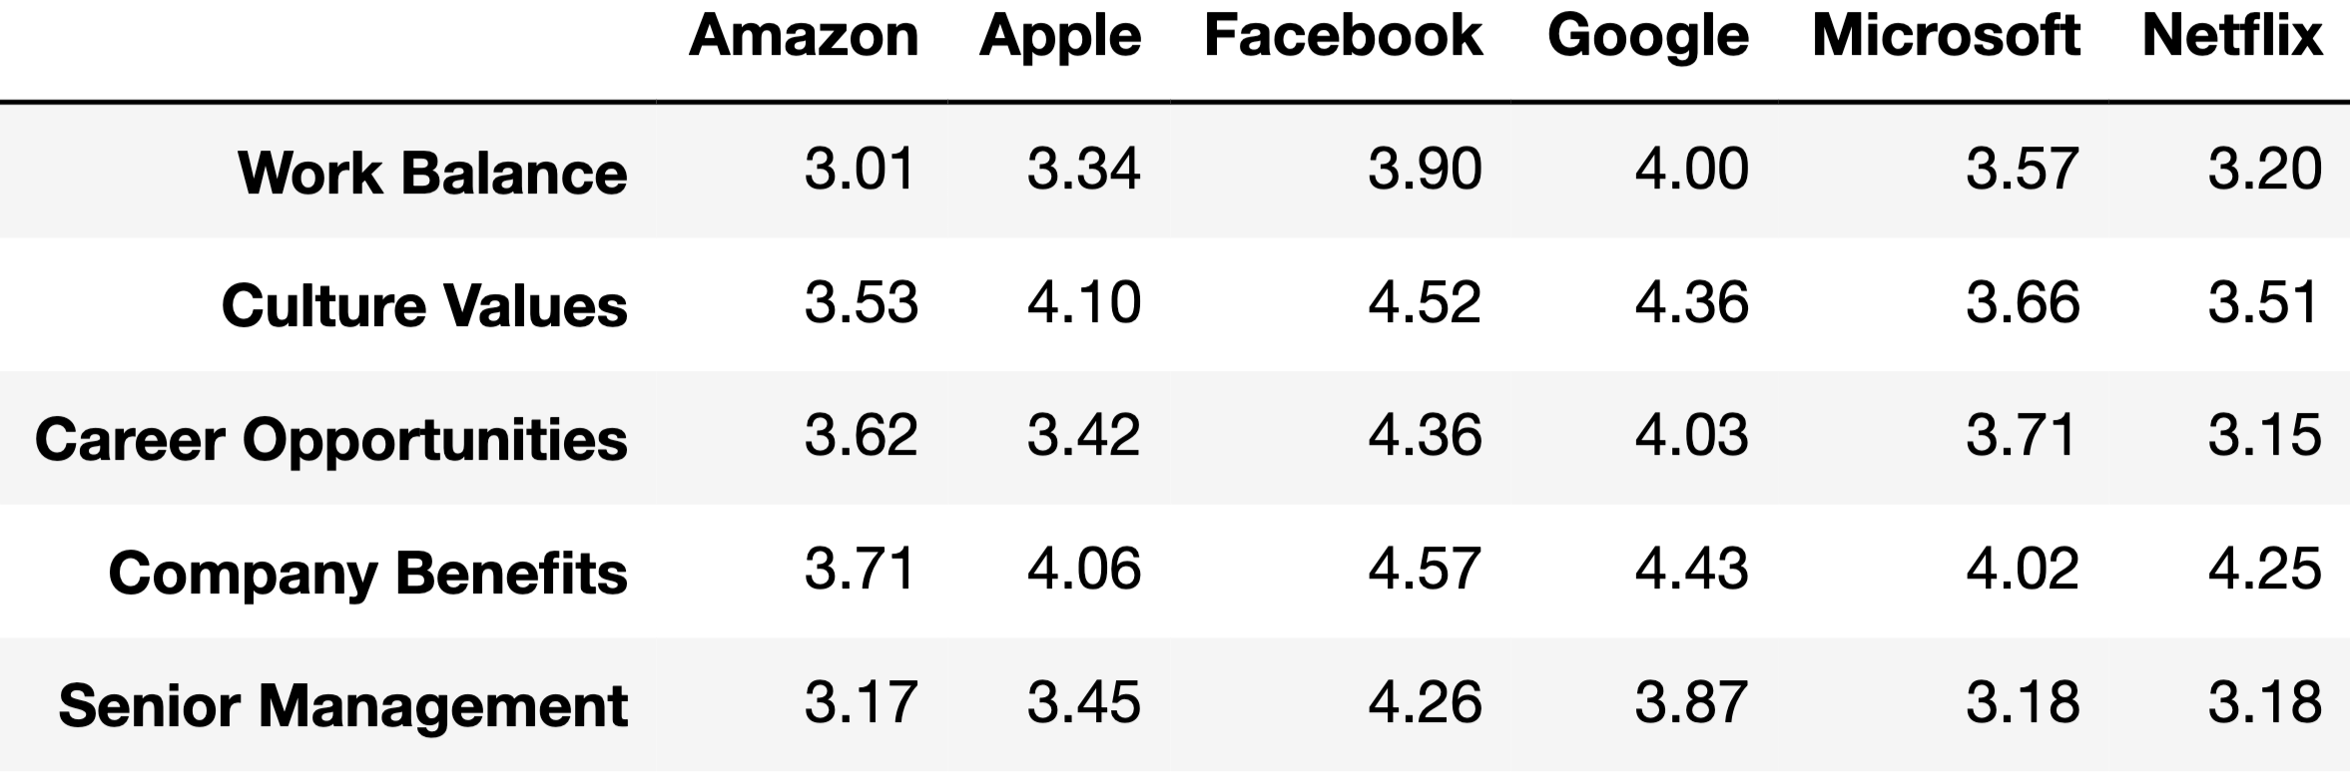

Table 1. Average Stars per Company

Table 1 shows that Google got the highest work-balance rating. Amazon falls short when comes to provide employees with a better work-life balance. In the next category, Facebook got the highest rating in Culture Values, whereas Netflix got the lowest rating followed by Amazon. To understand how the companies helping employees advance their career, Facebook top the position by getting the highest rating. Netflix again got the lowest rating. When referred to the rating for company benefits, Facebook got the highest rating whereas Amazon got the lowest. Facebook again top the Senior Management category and Amazon got the lowest. The same distribution can be observed through Heatmap in Figure 9. Heatmap is very useful to visualize which intersections of the categorical values have a higher concentration of the data compared to the others. From the heatmap, the same can be observed where Facebook got the dark color due to the highest rating in most of the organization criteria whereas Amazon seems to have got the lowest rating followed by Netflix.

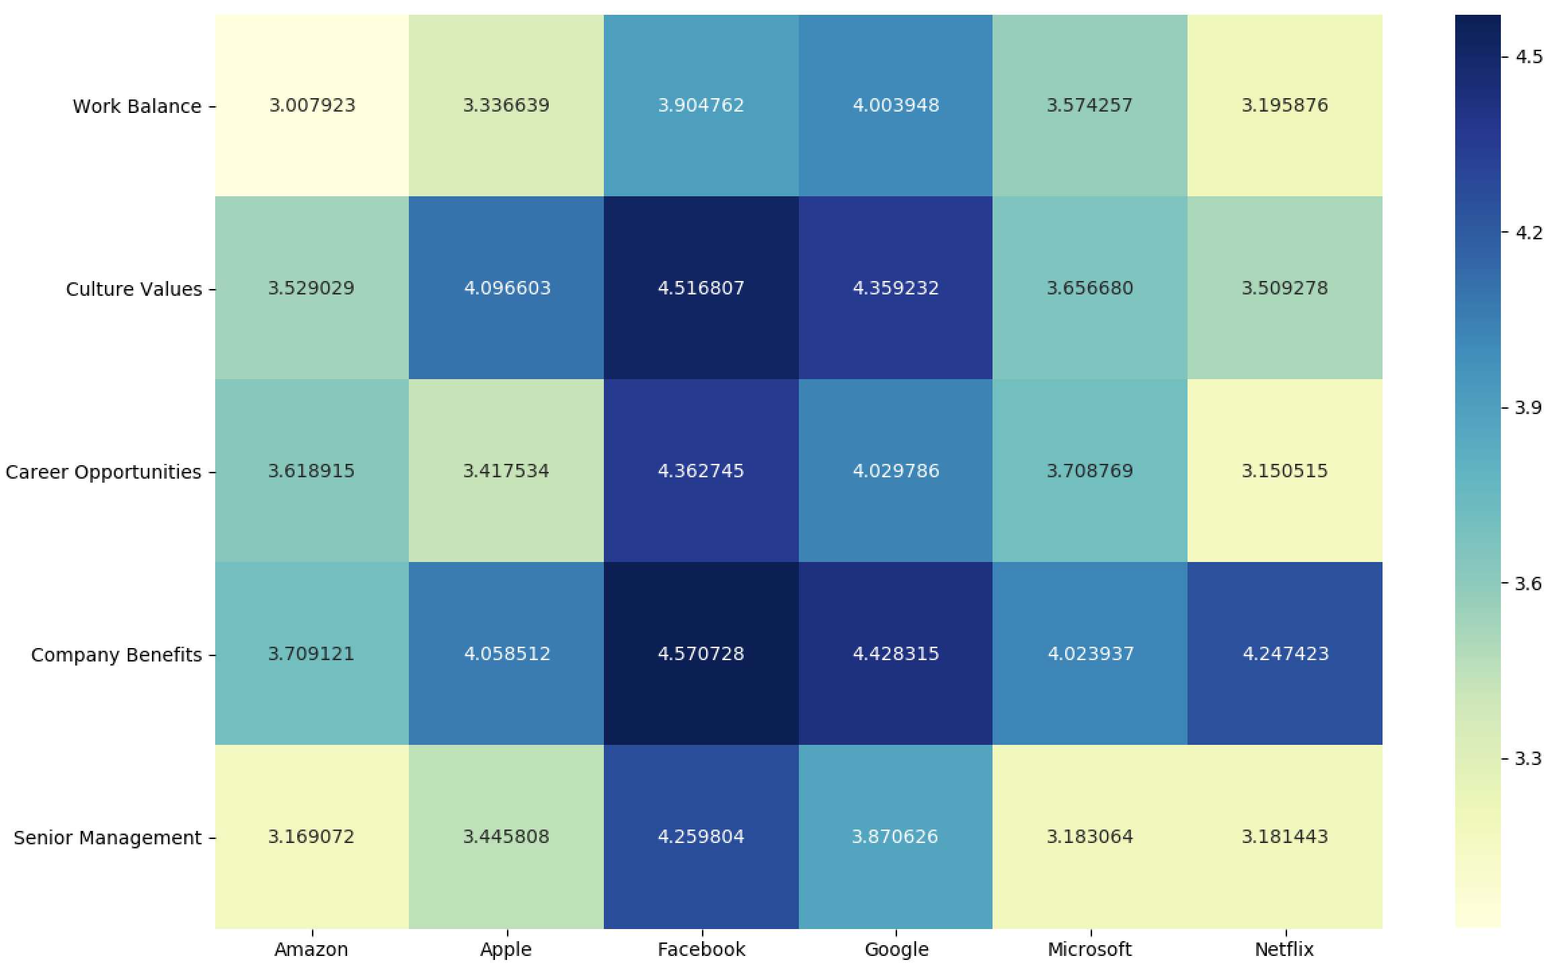

Figure 9. Average Stars Heatmap

To analyze more on the review comments, the word cloud was generated to analyze the weight of the texts present in the review comments as shown in Figure 10. Word Cloud is a visual representation of text data in the form of single words whose weight is displayed by their size and color. It is an excellent option to help visually interpret text and help in quickly gaining insight into the most prominent items in a given text. To generate the word cloud, first, it goes through the text and counts the frequency of each word. The process involves normalizing the texts, removing stop words and then generating the word frequency list. The words are then ordered and it starts appearing based on the frequency. The word with the highest frequency will display first and the size will be bigger. The second word with less frequency will appear with a smaller size than the first one, then the third word appears and continues so on. To generate the word cloud for the dataset, first, all the punctuations were removed. After removing the punctuations, the stop words are also removed. The word tokens were then lemmatized using the WordNetLemmatizer function. Then for each of the company’s pros and cons attributes, top twenty words were generated. After generating the top twenty words from each of the companies, the word cloud was generated for all the companies, to visualize the texts from the Pros and Cons. Some of the tops highlighted texts under Pros for most of the companies were “environment”, “perk”, “amazing”, “smart”, “employee”. Some of the tops highlighted texts under Cons for most of the companies were “project”, “big”, “team”, “life”, “balance”. From the highlighted texts, it can be interpreted that employees enjoyed the positive side of working in those companies like better benefits, work environment, smart work cultures, but the negative sides were poor work-life balance, a bigger team, poor senior management.

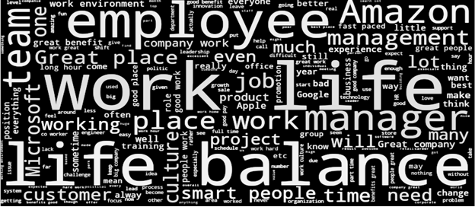

Figure 10. General Review Word Cloud

The data was then further analyzed to find out the overall score for each of the companies. In Figure 11, it can be observed, considering all the stars, Facebook got the highest score and can be considered as the best company to work. It is followed by Google, Apple, and Microsoft. Netflix got the lowest score, though it also got a very smaller number of feedbacks, so it cannot be deduced that it is not the best company to work. Considering the total number of reviews, review count per employee type and distribution of stars, Amazon got the lowest score and can be considered as the worst place to work.

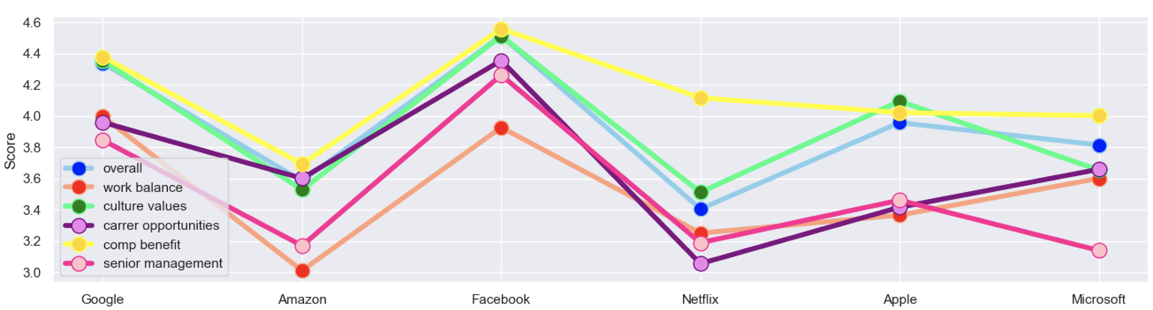

Figure 11. Average Score per Company Line Chart

**2.2 Models**

**2.2.1 Naive Bayes**

Basically, Naive Bayes is also a simple and popular, yet effective and friendly, model as a machine learning classifier. It belongs to the supervised learning family. The core of such probabilistic classifier is the Maximum A Posteriori decision rule in a Bayesian setting. The simple Bayesian network has been especially popular for text classification, and already a traditional solution to solve the spam detection problem. In short, the class or label the Naive Bayes model learns to predict is the result of the memory of the probability distribution of all the observations. The model then decides the label to assign to each unseen sample based on the calculated conditional probability. It is the probability of assigning a class to a sample given a specific set of features or attributes. The critical assumption of the Naive Bayes model is that every feature is independent of one another. It means the model will assume there is no correlation between any feature and so, their contribution to predicting the class is not impacted by other features. The decision to assign a class to an unseen sample is called the Maximum A Posteriori decision. It is a process to estimate the posterior probability to maximize the likelihood of seeing an example of that specific class. All in all, the Naive Bayes algorithm leverages on Bayes Theorem to learn the features best describe the examples provided in the training set. It relies on the Maximum A Posteriori decision rule to predict the class of each new sample provided in the test set. It is simple to develop and fast to compute. And, it requires small training dataset and works well for both binary and multi-class classification.

It is worth mentioning that what implemented in following tests is the Multinomial Naive Bayes model, a specific instance of a Naive Bayes classifier. Up to this point, the distribution of each feature is not defined specifically. The word Multinomial simply indicates that the distribution of each class is assigned as a multinomial distribution rather than others. Similarly, Gaussian Naive Bayes classifier assumes that the probability of each category is consistent with a Gaussian distribution. In probability theory, the multinomial distribution is a generalization of the binomial distribution and categorical distribution. The multinomial is used for a finite number of classes where order doesn't matter, while the normal distribution is used for continuous data, values that theoretically can take on an infinite number of values. It is reported that the multinomial distribution works well for data which can easily be turned into counts, such as word counts in textual data, which is also the reason to involve it in this work.

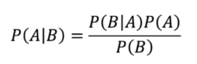

Figure 12. Naive Bayes Formula

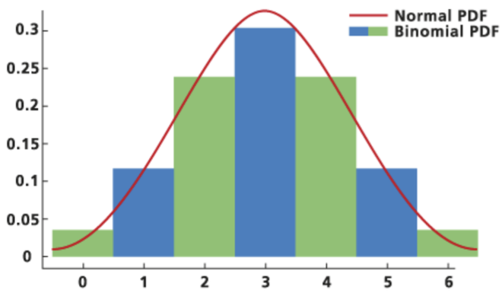

Figure 13. Binomial and Normal Distribution Plot

**2.2.2 Support Vector Machines**

Support vector machine, abbreviated as SVM, is a naive algorithm in every machine learning expert's arsenal. It is highly preferred by many due to its significant accuracy without a large amount of computing power. Although SVM can be used for both regression and classification tasks, it is more widely applied in classification objectives. The idea of SVM is not so hard to mathematically understand, another advantage. Its objective is to find a hyperplane in an n-dimensional space that distinctly classifies the data points, where the “n” stands for the number of features. Yet, it is highly possible that many hyperplanes are able to separate the two classes of data points. So, the algorithm aims to find a plane that has the maximum margin, the maximum distance between data points of both classes. The reason is that the margin distance offers the reinforcement so that the coming data points can be classified with more confidence. Hyperplanes can be treated as decision boundaries to classify the dataset. Points falling on either side of the plane can be attributed to different classes. The dimension of the hyperplane depends upon the number of features. One thing worthy to note is the support vector. Support vectors are data points closer to the hyperplane and depended for its position and orientation. Thus, these support vectors then decided the boundary and maximize the margin of the classifier. Any change of the support vectors can change the position of the hyperplane.

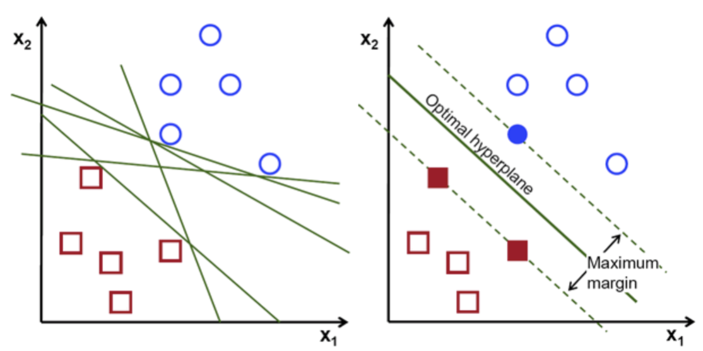

Figure 14. SVM Classification Process

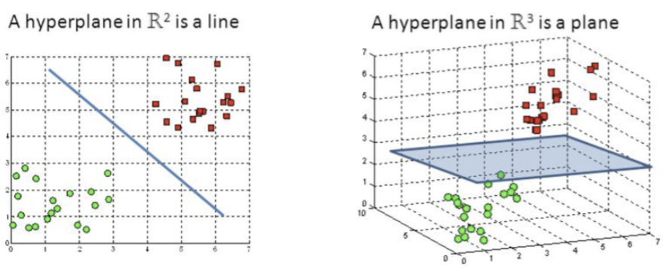

Figure 15. Hyperplane in SVM

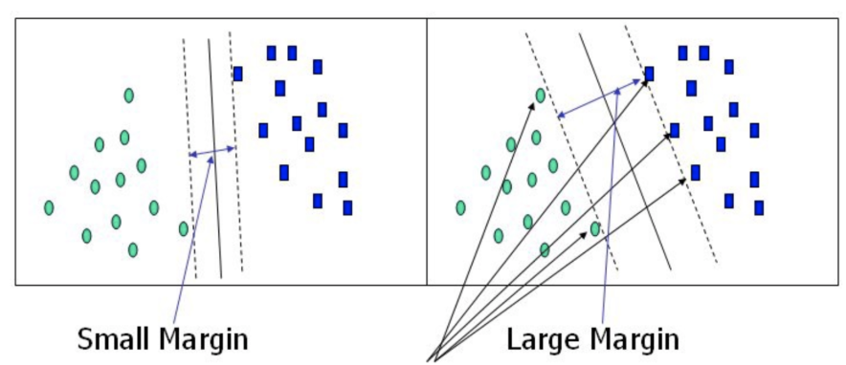

Figure 16. Margin in SVM

The Support Vector Machine (SVM) can be traced back to the study of Vladimir Vapnik in the 1960s. It was pretty much overlooked until the 1990s and is now still one of the most popular machine learning algorithms. It works quite well for both classification problems and regression tasks. As described, SVM is highly preferred by many due to its excellent performance without the need for a large number of computing resources. The objective of SVM is to find a hyperplane in an n-dimensional space so that it is able to classify the data points distinctly. The maximum margin, the maximum distance between data points of both classes, is in charge of judging the most appropriate hyperplane. Support vectors are the data points nearest to the hyperplane, required to calculate the maximum margin. Removing any of them would alter the position of the dividing hyperplane, so they are regarded as the critical elements of a data set. However, the common case is that the distribution of the dataset is linearly non-separable, as a result of which, the target hyperplane is not easy to find. To handle such problem, kernel functions are proposed to map the data points to a high-dimensional and separable space. The lifting operation is so named as kernelling. These kernel functions can be various types such as linear, nonlinear, polynomial, radial basis function (RBF), and sigmoid. It is also one of the hyperparameters to tune for greater performance. SVM is often used for text classification tasks such as category assignment and filtering spam. In the following tests, it will be involved in the employee reviews sentiment analysis and the comparison with the Multinomial Naive Bayes model.

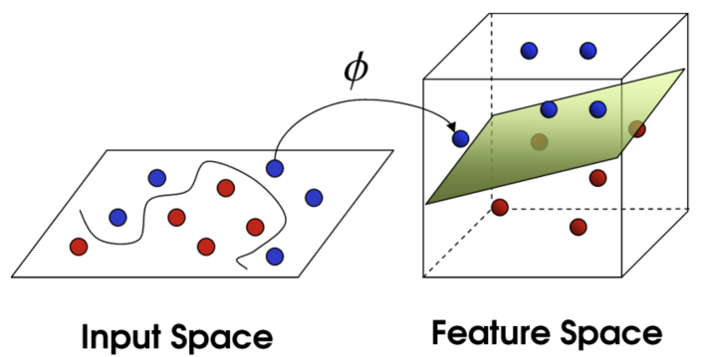

Figure 17. SVM Kernel Trick

**3. Results**

In addition to the described analysis, this work also aims to investigate whether a model can learn from the data to correctly recognize the employee attitude based on pure textual information. In the contrast between Multinomial Naive Bayes (MNB) and Support Vector Machines (SVMs), the performance is not only the exact prediction results but also the time cost. To measure the prediction results, several metrics are covered such as accuracy, f-measure, precision, and recall. The major indicator is the average accuracy because the sentiment analysis is actually a binary text classification task. For others' convenience to reproduce the same experiments, the random seed is fixed as 0, the same as what used for splitting out validate set. Both models are implemented with the help of modules offered by Scikit-learn. For any Python programmer, the Scikit-learn library is always the first choice for them to bring machine learning into a production system. The text preprocessing step heavily depends on the Natural Language Toolkit (NLTK). NLTK is one of the most popular Python frameworks for working with human language. It is well-known as a perfect start point with NLP since it's packed with clear examples and friendly Application Programming Interface (API).

In terms of the text representation, two popular approaches, Term Frequency (TF) and Term Frequency-Inverse Data Frequency (TF-IDF), are involved based on the n-gram term distribution. In this work, 1-gram denotes unigram and 2-gram denotes bigram. Given that, TF stands for the frequency of a token, either unigram or bigram, in each document in the corpus. IDF is defined as a score to represent how rare a word is across documents. In short, IDF is a measure of how rare a term is. The rarer a term is, the higher its IDF score will be. In this way, TF-IDF is a normalized text vectorization which helps to highlight specific feature words and to ignore words that appear too frequently such as stop words, punctuation, and personal pronouns. A total of three vectorizers are employed here including bigram count vectorizer, bigram & unigram count vectorizer, and bigram & unigram TF-IDF vectorizer. The modules of Scikit-learn fully support all of these text transformations.

As the baseline, a positive majority vote method can correctly recognize 86.3% of the entire dataset. In the end, given the unigram count feature map, MNB achieved 87.3% accuracy with the alpha as 1.0. The same model trained on both unigram and bigram feature maps got 86.3% accuracy. When it came to the TF-IDF bigram vectorization, the accuracy rose back to 87.3%. There are not many parameters to tune for naive Bayes models. The training process can be completed in 1.2 seconds, which is really fast. Usually, a linear support vector machine can do better for most text classification tasks, although it is also a bit slower than naive Bayes. The code environment is kept the same but the model is changed to SGDClassifier, the SVM model module of Scikit-learn. The parameters are kept as the default settings such as 0.0001 for an alpha, None for class weight, 0.1 for epsilon, and l2 loss for the penalty. In the end, SVM can achieve 88.5% accuracy for unigram word features and increased to 88.6% with the assistance of both unigram and bigram text vectorization. However, its performance dropped a little bit when feeding TF-IDF features. The entire training phase of an SVM model took almost 2 seconds. After that, the same experiments are repeated using the full training set, 67122 reviews, with 10 folds cross-validation. The final result is the same as what got in the previous one-time testing. The result indicates that the SVM with unigram and bigram frequency as features is the best one among all the tests. Detailed evaluation matrix can be found in the following table. One thing to be noted is that there is still much space for improving SVM, but little for MNB.

|  |  |  |  |  |  |  |
| --- | --- | --- | --- | --- | --- | --- |
| **Model\Vectorizer** | **Uni Count** | | **Uni & Bi Count** | | **Uni & Bi TFIDF** | |
| **MNB** | 0.873 | +/- 0.002 | 0.863 | +/- 0.003 | 0.873 | +/- 0.001 |
| **SVM** | 0.885 | +/- 0.003 | **0.886** | **+/- 0.004** | 0.880 | +/- 0.001 |

Table 2. Evaluation Matrix via 10 Folds Cross-validation

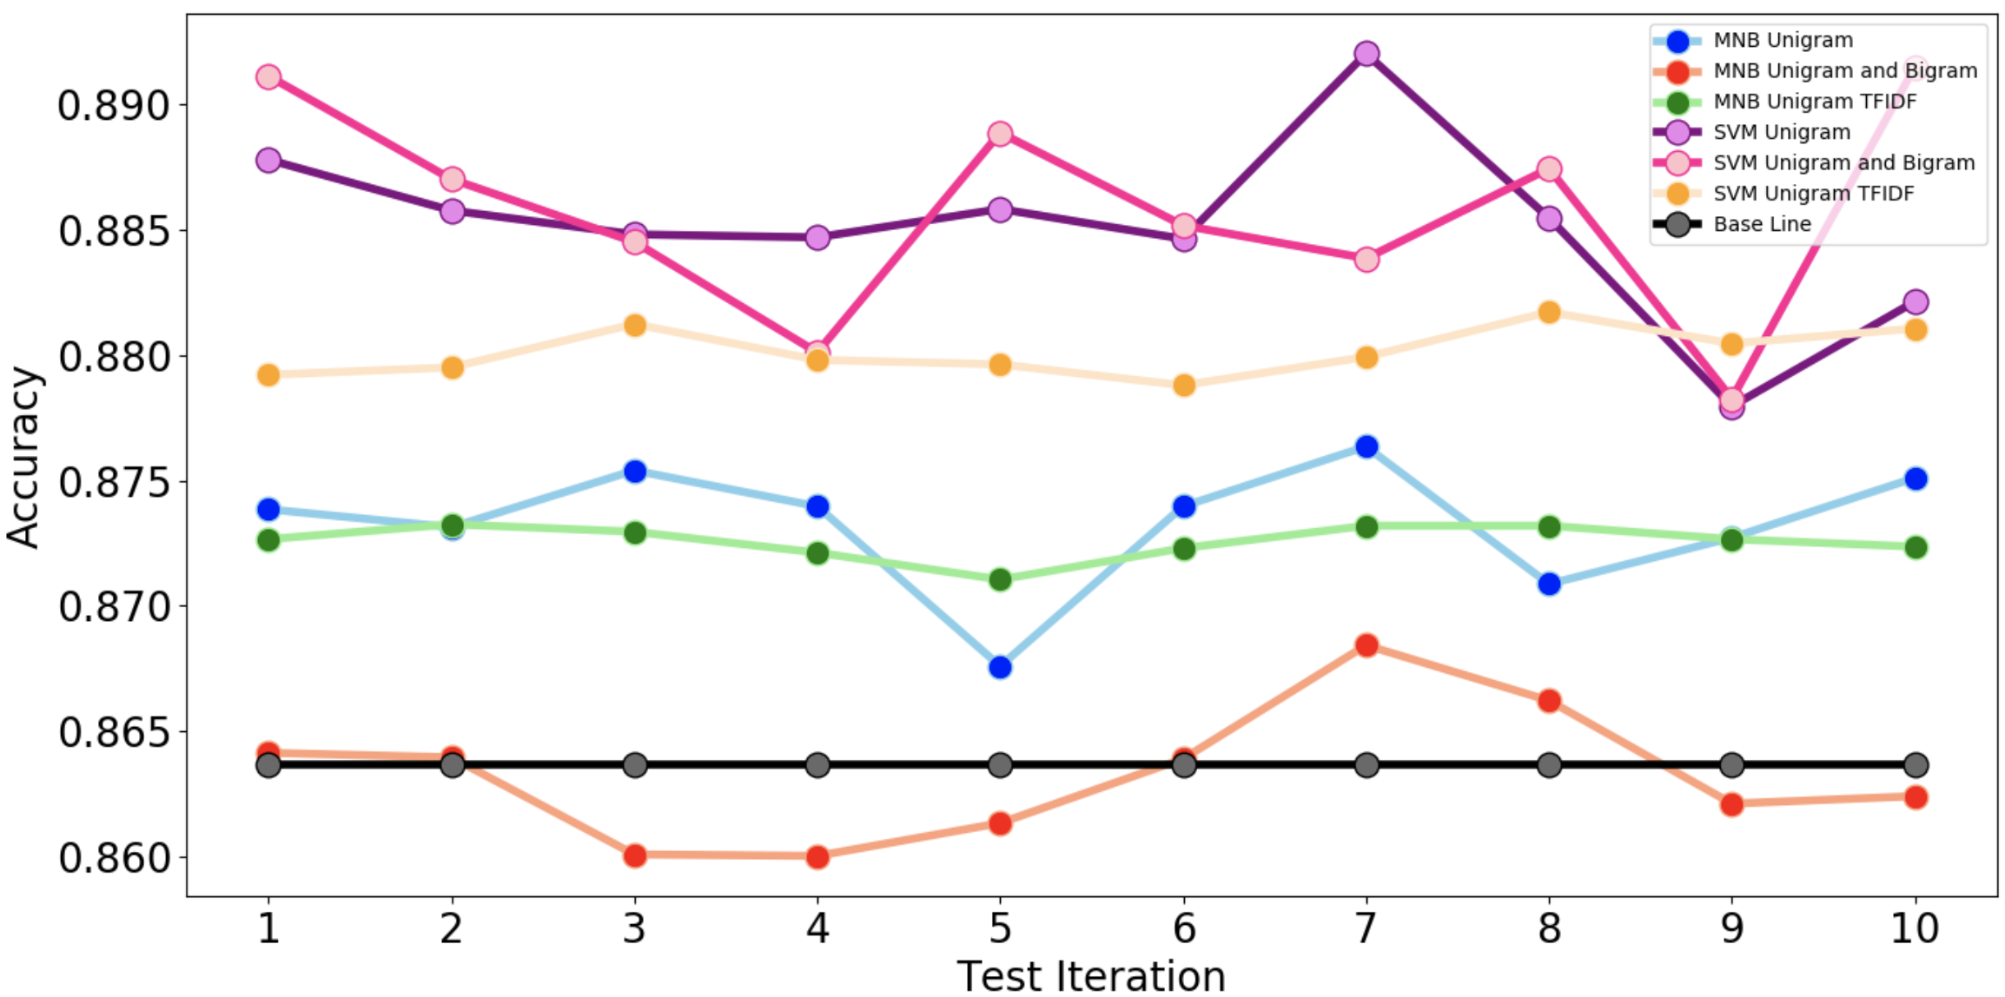

Figure 18. Evaluation Line Chart via 10 Folds Cross-validation

**4. Conclusion**

Overall this work aims to provide a detailed analysis of the attitude of employees towards companies. The analysis is multifaceted, covering the unstructured reviews as well as direct overall ratings. A total of six companies are reviewed, including Amazon, Apple, Facebook, Google, Microsoft, and Netflix. According to the description analysis, the massive amount of data reflects several valuable information. Today's employees are increasingly used to express their opinions about their employers. And when they leave the company, they often remember the happy time at the office and give a better evaluation than the current staff does. Without doubt, both Facebook and Google are relatively two best employers based on a comprehensive evaluation. Furthermore, two models, Multinomial Naive Bayes and Support Vector Machines, are trained to understand these employees' comments in the sentiment analysis. Both of them are popular approaches and wide-used by most experts in the data science field. Three text vectorization methods are employed as well. Given the combination of each text vectorizers and each model, there are totally six models ready for the evaluation. The measurement is based on four indicators, namely accuracy, precision, f score, and recall. Finally, the SVM with both unigram and bigram word features won the game.

In sentiment analysis, the most important feature may be the combination of words rather than a single word itself. When people want to express their opinions more accurately, they often need more words. The participation of any word may affect the entire context. For example, "not good" is certainly different from "good." As specific word has meaning but combining the words may be more helpful in understanding the phrase precisely. In preprocessing, the n-gram is basically set of occurring words within a given window so when n=1 it is unigram; n=2 it is bigram; n=3 it is trigram and so on. With the growth of the gram size, machines will split sentences into small groups of words to understand its meaning instead of treating each token individually. The improvement caused by the addition of bigram features suggests that the attendance of bigram information does help the model to understand the context better. Since unigram features are still in the feature space, it makes sense that more information often leads to a better prediction. As indicated above, move vocabulary, and their combinations often enrich a sentence and thus make the machine, as well as everyone, understand the meaning more easily.

After analyzing the data and applying all the required models and methods, it is concluded that out of all the six companies, Facebook and Google are considered to be the best companies to work. Even though all the companies received considering amount of employee’s feedback, though most of them still lack the work-life balance. When referred to the star rating, all the companies got less score. Only Google got the better score out of all the companies. Also, in the word clouds, it displayed that the top cons for all the companies are life and balance, which reveals that work-life balance is still a bigger issue for all the big tech giants. Though, they lack in the work balance, all of them mostly care for the cultural values and compensation and benefits. Compensation and benefits are one of the biggest factors in the job. It hugely impacts employee’s performance and attitude to work. Performance driven bonus and other attractive perks attract the talent resource pool. The competitive compensation strategy is one of the main reasons why these companies are now the dream jobs for most of the tech job seekers. Also observing the review trend, it can be concluded that employees are now more active in expressing themselves. During the early 2000s, the review process was very low and none of the companies got any high amount of feedback. But once the career websites have started promoting the idea of a company rating concept, there can be seen an increasing trend of the company review process. Also giving feedback anonymously help the employees not to reveal their identity and hence employees enjoy the freedom of giving the reviews. There is still a chance where it can result in bias feedback which can then impact the company's image negatively. But there are several other factors which also help the company to maintain its position in the industry sector.

**Reference**

[1] Biber, D. (1991). Variation across speech and writing. Cambridge University Press.

[2] Karlgren, J., & Cutting, D. (1994, August). Recognizing text genres with simple metrics using discriminant analysis. In Proceedings of the 15th conference on Computational linguistics-Volume 2 (pp. 1071-1075). Association for Computational Linguistics.

[3] Hatzivassiloglou, V., & Wiebe, J. M. (2000, July). Effects of adjective orientation and gradability on sentence subjectivity. In Proceedings of the 18th conference on Computational linguistics-Volume 1 (pp. 299-305). Association for Computational Linguistics.

[4] Sack, W. (1994, July). On the computation of point of view. In AAAI (p. 1488).

[5] Turney, P. D. (2002, July). Thumbs up or thumbs down?: semantic orientation applied to unsupervised classification of reviews. In Proceedings of the 40th annual meeting on association for computational linguistics (pp. 417-424). Association for Computational Linguistics.

[6] Pang, B., Lee, L., & Vaithyanathan, S. (2002, July). Thumbs up?: sentiment classification using machine learning techniques. In Proceedings of the ACL-02 conference on Empirical methods in natural language processing-Volume 10 (pp. 79-86). Association for Computational Linguistics.

[7] Cortes, C., & Vapnik, V. (1995). Support-vector networks. *Machine learning*, *20*(3), 273-297.

**Appendix**

